Aquia Harbour Police Chief
End Of Watch
Craig Cunningham
09/20/1968-09/16/2023
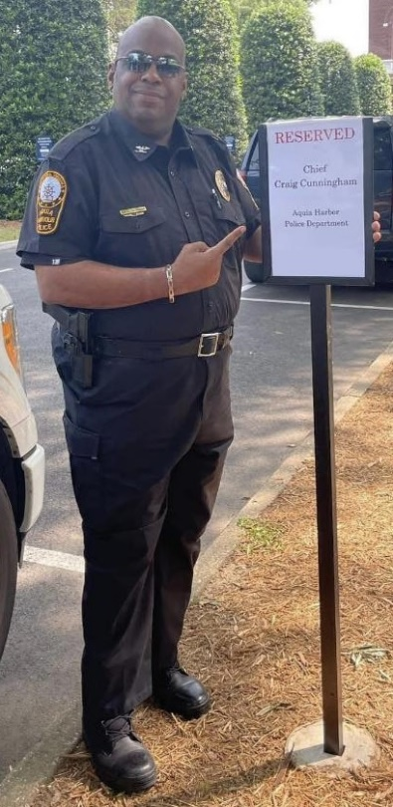

Today we lost a wonderful man who served the community of Aquia Harbour with honor, courage, and integrity.

Chief Cunningham was a public servant who served over 30 years in New York, Prince William County PD and came to Aquia Harbour PD in 2019. He began his career here at Aquia Harbour as an officer and through his dedication and commitment, he was proudly appointed as our Chief of Police.

Chief Cunningham was a pillar of excellence and a great role model for the residents of the Harbour. He always served with fairness, a smile on his face, and a positive outlook in any situation, making the Harbour a better place to live.

With his large personality, Chief Cunningham has made a lasting impression, not only in Aquia Harbour but on all those he's come across.

"Unit 801, you have made your family and the people you have served very proud. Your presence with the Aquia Harbour Police Department will always be remembered and never forgotten. May you rest in peace."

